Transport Sector
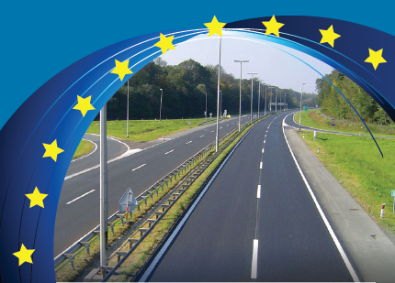

PRIORITY AXIS 1
CORRIDOR X MOTORWAY COMPLETION

Specific objectives:
- To facilitate movements of people and goods with the EU and its regional neighbors by completing national sections of Corridor X
- In so doing to support improved living standards
- To promote sustainable development, especially through minimizing the adverse effects of transport on the environment and through improving transport safety
Rationale:
Analysis of the national and regional transport conditions indicated the following weaknesses:
- Limited connections by rail or road with neighboring states
- Unsatisfactory road conditions in local network
- Cross border delays
- Inadequate funding available to fulfill all transport infrastructure project requirements
Expected results:
- Improved safety and quality of service of the country’s transport system for both passengers and freight traffic
- Better connections between the main cities
- Better connections with the main destinations in neighbouring countries
Commercial Beneficiaries:
- Importers and exporters of goods and products, including agricultural products
- Stakeholders involved in moving goods around the country, or across South Eastern Europe
Further Benefits:
- All road users will benefit from:
- Reduced travel time
- A modern highway with high safety standards
- Reduced number of accidents, injuries and fatalities

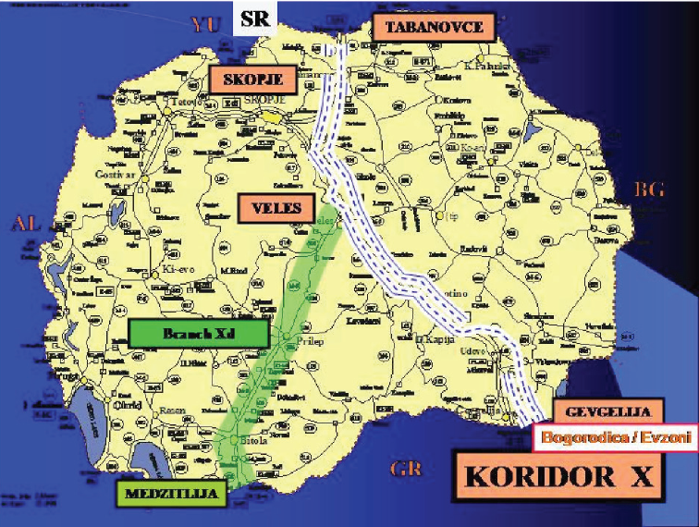

Measure 1.1 – Upgrading Remaining Link
Along the Corridor X to the Level of Motorway

Specific objectives:
- To construct the remaining highway link on Corridor X to level of motorway
- To eliminate dangers and delays that occur in this sub- standard stretch
- To reduce accidents and ensure safer travelling environment
- To limit the harmful impact of road traffic on the environment
- To increase the capacity of the connections with neighboring countries
Rationale:
- Corridor X is the most important element of the core transport network linking SEE countries from Turkey to Austria
- The E-75 is mostly a four-lane motorway and completion of Corridor X will enhance the possibilities of increased traffic by linking the central Europe with the port of Thessaloniki
- This road axis is classified as part of the main and most important corridor of the national road network of the country
- The measure refers to a missing section of the Corridor X
Benefits:
- Reduced vehicle operating costs and number of accidents,
- Time savings
- Indirect employment for production of material and equipment during construction and operation/maintenance of the project
- Additional jobs anticipated with development of motorway service areas along the entire Corridor X
Works involved:
- The new motorway section will comprise a 28 km stretch in the south part of the country between Demir Kapija and Smokvica, along the western bank of the river Vardar
- The project involves the construction of 6 bridges, 2 twin tunnels and 2 level intersections near Miravci and Smokvica
Eligible Actions:
- Supervision of works
- Highway construction
- Reconstruction or upgrade of new motorway
- Associated support structures
- Related procurement contracts
- Assistance with tendering and contracts (tender specifications,
evaluation, preparation of contracts, etc.)
Selection Criteria:
- Consistency with national and regional policies
- Readiness of project for implementation
- Positive impact on population, minimum impact on nature
- Adequate management capacity of final beneficiary
- Sufficient financial capacity of the beneficiary and available co-financing

Project Cost:
- € 210 million in total
- Funded by state budget through loans provided by EBRD and EIB
- EUR 45 million grant contribution from the European Union’s IPA
- To be completed by 2018
Final Beneficiaries:
- Ministry of Transport of Transport and Communications
- Agency for State Roads

On 8th September 2012, a cornerstone was set near Demir Kapija, thus marking the start of construction works of a new 28 km motorway section from Demir Kapija to Smokvica, as part of the Pan-European Corridor 10. With construction of this section the Pan European Corridor X, when completed, on the whole territory of Republic of Macedonia will have high motorway standards

PRIORITY AXIS 2 – UPGRADING AND
MODERNIZATION OF THE TRANSPORT INFRASTRUCTURE

Identified Sector Constraints:
- Limited connections by rail and road with neighboring states
- Unsatisfactory road condition in local network
- Unsatisfactory level of financing of road maintenance
- Constraints accruing from a very limited railway infrastructure network
- Backlog in maintenance for rail infrastructure
- Cross border delays
- Inadequate funding available to fulfill all transport infrastructure project requirements
Activities under this Axis:
- Rehabilitation of the existing rail links
- Construction of missing links
- Construction of road infrastructure to the level of motorway, so that these two important transport links will then be operational along the strategic East-West and North-South Corridors
- Project preparation studies
- Feasibility studies
- Cost-benefit analyses
- Environmental Impact Assessments
- Design documentation
- Tender documentation of the projects where pre-feasibility studies exits

Measure 2.1: Improving the Rail Infrastructure along the South East Europe Core Regional Network
Specific objectives:
- To rehabilitate the rail links along the international Corridors X and VIII
- Provide national and international railway links
- To improve safety and security
- To reduce travel time for passengers and freight railway transport
- To increase the capacity of connections with neighboring countries along the Corridors
- To promote sustainable development especially through minimizing the adverse effects of transport on the environment and through improving transport safety

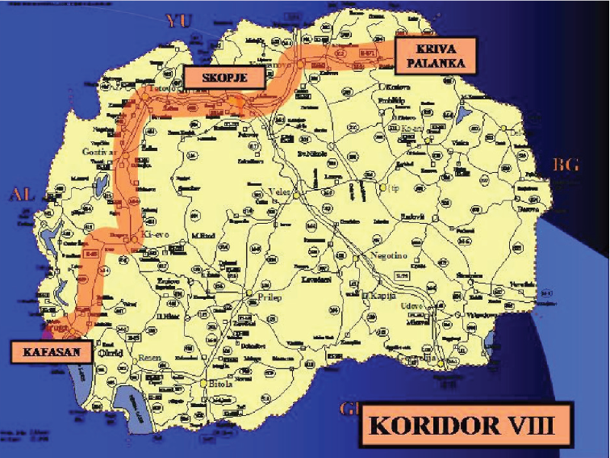

Rationale:
- The overall condition of the rail network is obsolete as compared to European standards
- Poor rail infrastructure
- Missing links towards Bulgaria and Albania
The completion of the remaining rail links on Corridors VIII and X will result in the following benefits:
- Increased domestic passenger and freight movements
- Increased international passenger traffic
- Increased use of rail for trade imports and exports
- Increased international transit traffic by rail
Quick Facts:
- Corridor VIII rail infrastructure runs East – West and is 315 km in length within the Country
- The eastern part of the Corridor VIII towards Bulgaria requires 89 km to be built
- The Western section towards Albania requires 66 km to be built
Eligible actions under this Measure:
- Project preparatory studies such as feasibility studies, cost-benefit analyses, environmental impact assessments, design documentation and assistance with tendering and contracts (tender specification, evaluation, preparation of contracts, etc).
- Rehabilitation and upgrading of the existing railways in accordance with EU technical standards
- Post-completion restoration activities, related to the measure
Selection Criteria:
- Consistency with national and regional policies
- Readiness of project for implementation
- Adequate management capacity of the final beneficiary
- Sufficient financial capacity of the beneficiary and available co-financing
- Professional competence of the management team
Measure 2.2: Improving the Road Infrastructure along the South East Europe Core Regional Network
- Development of road infrastructure along Corridor VIII
- Provide national and international motorway links along Corridor VIII
Eligible Actions:
- Project preparation studies (as before)
- Upgrade of existing motorways in line with the EU technical standards
Post-completion restoration activities, related to the measure
Selection Criteria:
- Consistency with national and regional policies
- Readiness of the project for implementation
- Positive impact on population, minimum impact on nature
- Adequate management capacity of final beneficiary
- Sufficient financial condition of the beneficiary and available co-financing

